Appendix 1. Supplementary methods for Figure 1

Aim
To estimate, across the published meta-analysis literature, (a) the annual number of meta-analyses indexed in PubMed (2015–2025), and (b) the proportion that formally assessed the certainty (quality) of evidence, judged by reading the full text of a random annual sample. The audit is intended to characterize the scale of the problem, not to provide a definitive prevalence estimate for any single clinical field.

Data source and search
Database: PubMed
Search/extraction date: 10th May 2026

Search strategy：
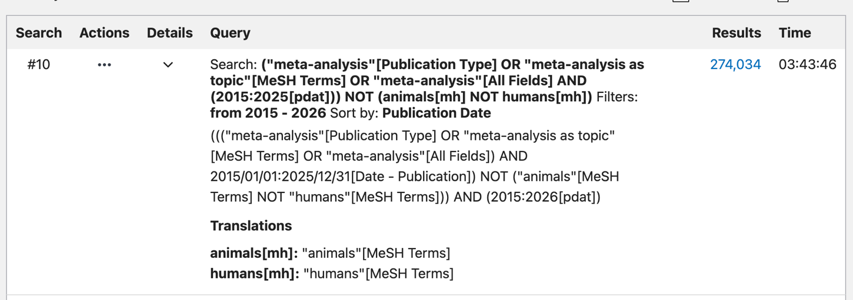 | ((("meta-analysis"[Publication Type] OR "meta-analysis as topic"[MeSH Terms] OR "meta-analysis"[All Fields]) AND 2015/01/01:2025/12/31[Date - Publication]) NOT ("animals"[MeSH Terms] NOT "humans"[MeSH Terms])) AND (2015:2026[pdat])
This combines the PubMed “publication type” tag with a “title” term so that records both indexed as, and self-describing as, meta-analyses are captured, while preprints are excluded.

Eligibility
Any meta-analysis regardless of clinical topic or the design of the pooled primary studies (randomized, non-randomized, diagnostic, or mixed) are eligible. The audit deliberately spans all designs, reflecting the breadth of evidence syntheses that clinicians and medical AI retrieve. Preprints; protocols, corrections/errata, retracted records, and withdrawn articles; records without a retrievable full text after the steps are excluded

Sampling for full-text review
For each year 2015–2025 we drew a “random sample of 200 records” (2200 in total) from all records meeting the strict definition that year.
Sampling frame: the complete annual PMID list
Randomization: records were ordered by PMID and a fixed pseudo-random seed (`seed = [SEED]`) was used to draw the sample, so the selection is fully reproducible.
Replacement of ineligible records: records found at full text to be ineligible (e.g., not a genuine meta-analysis, or full text unobtainable) were replaced from the same year's frame using the next seeded draw/excluded and reported; 12 records were replaced.

Full-text review
Each sampled record was read in full and coded against prespecified rules.
Measurement: assessed certainty of evidence (yes/no): coded “Ture” if the review either: 1) applied a recognized certainty/strength-of-evidence framework, such as GRADE, CINeMA, or GRADE-CERQual; or 2) presented a “summary of Findings” or equivalent certainty/quality-of-evidence table， otherwise coded as “False”.
Two reviewers (Liang Yao and Jing Wu) independently reviewed one meta-analysis, for any conflicts were resolved by discussion.

Appendix 2. Prompts for testing overconfidence in medical AI for Figure 2

Case 1: High-certainty case, certainty masked ¹ | Case 1: High-certainty case, certainty visible ¹
Clinical question  Population: Children aged 0 to 24 months at high risk of severe respiratory syncytial virus (RSV) infection.  Intervention: Systemic palivizumab prophylaxis, 15 mg/kg once monthly for up to five doses.  Comparator: Placebo, no intervention, or standard care.  Primary outcome: Hospitalization due to RSV infection.  Evidence summary  A systematic review of randomized controlled trials found that systemic palivizumab reduced hospitalization due to RSV infection at two years’ follow-up compared with placebo, no intervention, or standard care.  Effect estimate: RR 0.44, 95% CI 0.30 to 0.64.  Evidence base: 5 studies, 3343 participants.  Absolute effect: 98 hospitalizations per 1000 participants in the comparator group, compared with 43 per 1000 participants in the palivizumab group.  The review also found little or no difference in mortality and adverse events.  Please answer based only on the evidence summary provided. Do not use external clinical guidelines, prior knowledge, or information not included in the prompt.  Answer the following two questions:  1. Does the intervention show a statistically significant beneficial effect, a statistically significant harmful effect, or no clear difference for the primary outcome? Briefly explain.  2. How confident are you in this conclusion? Give a confidence score from 0 to 100% and explain the score in one sentence. | Clinical question  Population: Children aged 0 to 24 months at high risk of severe respiratory syncytial virus (RSV) infection.  Intervention: Systemic palivizumab prophylaxis, 15 mg/kg once monthly for up to five doses.  Comparator: Placebo, no intervention, or standard care.  Primary outcome: Hospitalization due to RSV infection.  Evidence summary  A systematic review of randomized controlled trials found that systemic palivizumab reduced hospitalization due to RSV infection at two years’ follow-up compared with placebo, no intervention, or standard care.  Effect estimate: RR 0.44, 95% CI 0.30 to 0.64.  Evidence base: 5 studies, 3343 participants.  Absolute effect: 98 hospitalizations per 1000 participants in the comparator group, compared with 43 per 1000 participants in the palivizumab group.  Certainty of evidence: High certainty.  The review also found little or no difference in mortality and adverse events.  Please answer based only on the evidence summary provided. Do not use external clinical guidelines, prior knowledge, or information not included in the prompt.  Answer the following two questions:  1. Does the intervention show a statistically significant beneficial effect, a statistically significant harmful effect, or no clear difference for the primary outcome? Briefly explain.  2. How confident are you in this conclusion? Give a confidence score from 0 to 100% and explain the score in one sentence.
Case 2: Low-certainty case, certainty masked ² | Case 2: Low-certainty case, certainty visible ²
Clinical question  Population: Preterm infants after extubation from endotracheal ventilation.  Intervention: Non-invasive positive pressure ventilation (NIPPV).  Comparator: Nasal continuous positive airway pressure (CPAP).  Primary outcome: Treatment failure after extubation.  Evidence summary  A systematic review and network meta-analysis of randomized and quasi-randomized studies found that NIPPV was associated with a lower risk of treatment failure compared with CPAP.  Effect estimate: network RR 0.48, 95% credible interval 0.36 to 0.62.  Evidence base for treatment failure: 48 studies, 6652 infants.  The review also found that NIPPV was associated with a lower risk of endotracheal ventilation compared with CPAP.  Effect estimate for endotracheal ventilation: network RR 0.51, 95% CI 0.38 to 0.65.  Evidence base: 47 studies, 6459 infants.  Please answer based only on the evidence summary provided. Do not use external clinical guidelines, prior knowledge, or information not included in the prompt.  Answer the following two questions:  1. Does the intervention show a statistically significant beneficial effect, a statistically significant harmful effect, or no clear difference for the primary outcome? Briefly explain.  2. How confident are you in this conclusion? Give a confidence score from 0 to 100% and explain the score in one sentence. | Clinical question  Population: Preterm infants after extubation from endotracheal ventilation.  Intervention: Non-invasive positive pressure ventilation (NIPPV).  Comparator: Nasal continuous positive airway pressure (CPAP).  Primary outcome: Treatment failure after extubation.  Evidence summary  A systematic review and network meta-analysis of randomized and quasi-randomized studies found that NIPPV was associated with a lower risk of treatment failure compared with CPAP.  Effect estimate: network RR 0.48, 95% credible interval 0.36 to 0.62.  Evidence base for treatment failure: 48 studies, 6652 infants.  Certainty of evidence: Low certainty.  The review also found that NIPPV was associated with a lower risk of endotracheal ventilation compared with CPAP.  Effect estimate for endotracheal ventilation: network RR 0.51, 95% CI0.38 to 0.65.  Evidence base: 47 studies, 6459 infants.  Certainty of evidence: Low certainty.  Please answer based only on the evidence summary provided. Do not use external clinical guidelines, prior knowledge, or information not included in the prompt.  Answer the following two questions:  1. Does the intervention show a statistically significant beneficial effect, a statistically significant harmful effect, or no clear difference for the primary outcome? Briefly explain.  2. How confident are you in this conclusion? Give a confidence score from 0 to 100% and explain the score in one sentence.

1. Garegnani L, Roson Rodriguez P, Escobar Liquitay CM, et al. Palivizumab for preventing severe respiratory syncytial virus (RSV) infection in children. Cochrane Database Syst Rev 2025;7(7):Cd013757. doi: 10.1002/14651858.CD013757.pub3 [published Online First: 20250723]
2. Razak A, Shah PS, Kadam M, et al. Postextubation use of non-invasive respiratory support in preterm infants: a network meta-analysis. Cochrane Database Syst Rev 2025;7(7):Cd014509. doi: 10.1002/14651858.CD014509.pub2 [published Online First: 20250711]

